**Creating dashboards – to get you started**

Task 1:

Install the packed app – sample reporting. Look through the types of reports and types of output and examples of SQL. Note useful ‘reports’ you could use.

Task 2: Look at sample application – dashboard.

Look at the code, maybe change code, get more ideas of ‘reports’ you might like to create.

Task 3: Create your own dashboard.

Create a new application.

Create a blank page in a new application

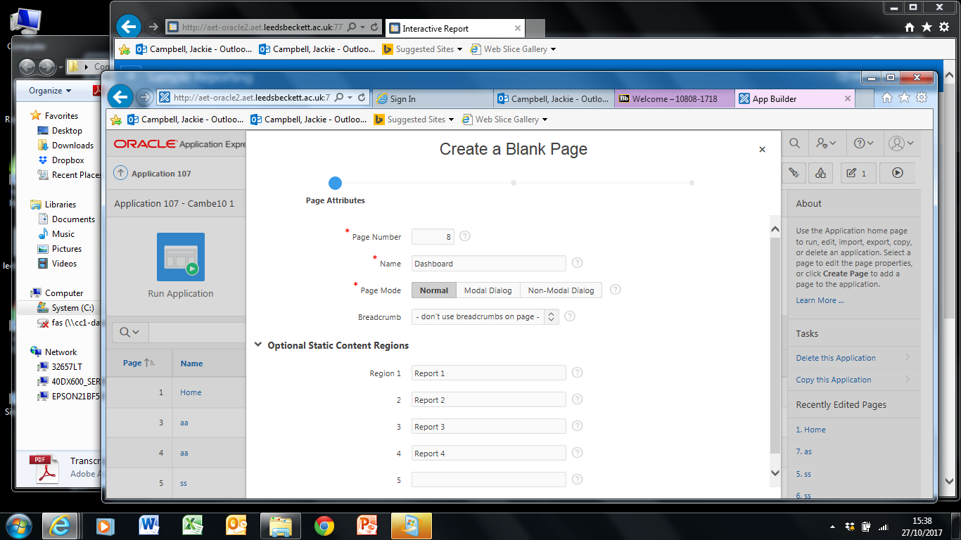

Run the application, edit the page (as above) and play around with the layout options (on the right on the screen).

Report 1 and Report 2 – sequence 20, 6 columns

Report 3 and report 4 – sequence 30, 6 columns

Report 1 and Report 3, new line - Yes

Report 2 and Report 4, new line – No

Run and should look like this (more or less)

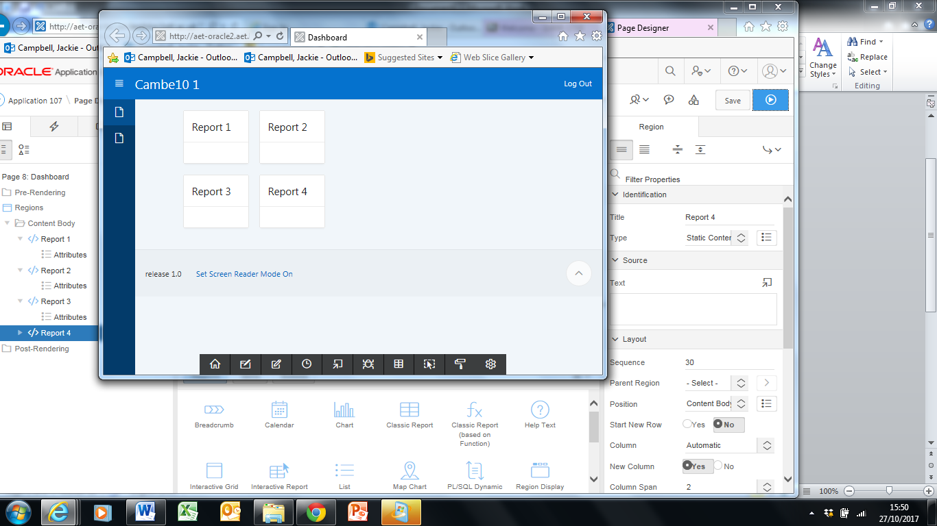

Edit again, select Report – source type, select classic report and add the SQL behind the report eg: SELECT * FROM emp

Run and it looks like:

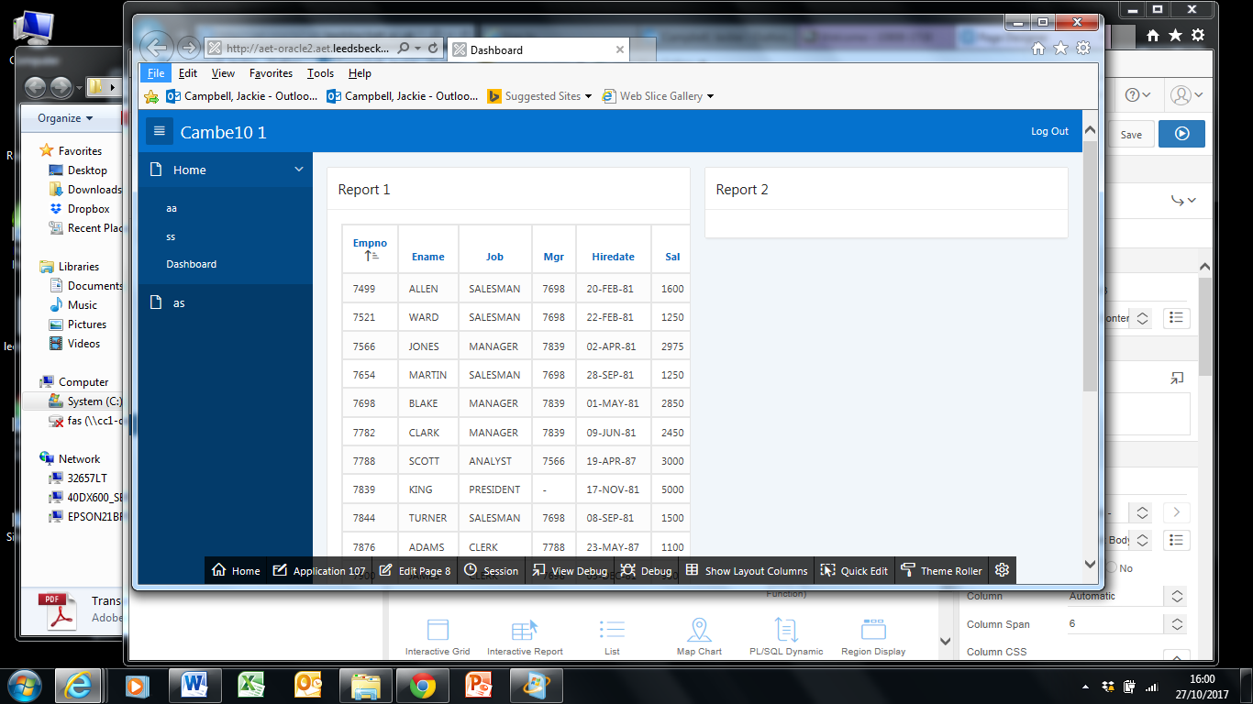

Now – play around.

With – the report source, the type of SQL.

Create a dashboard!